Develop a simple containerized application using Docker.

1. Index.html

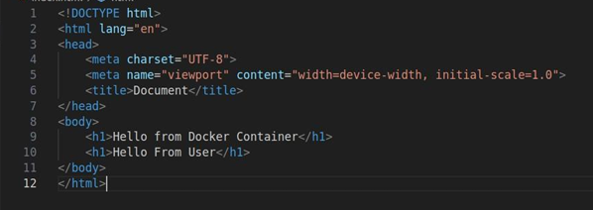

2. DockerfIle

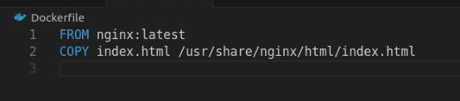

3. docker build -t my-docker-webapp .

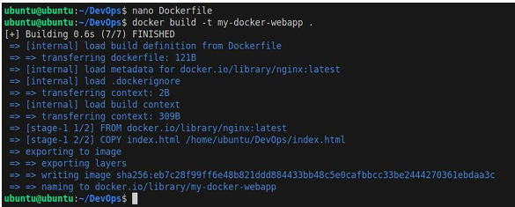

4. docker run -d -p 8080:80 –name webapp-container my-docker-webapp



5. docker ps



6. docker stop webapp-container



7. docker rm webapp-container



8. docker rmi my-docker-webapp

